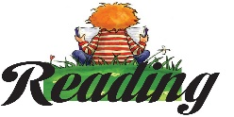
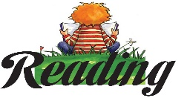
One Page Final Project
This Photo by Unknown Author is licensed under CC BY-SA-NC
This Photo by Unknown Author is licensed under CC BY-SA-NC
Connect four boxes vertically, horizontally, or diagonally to select your four required assignments. All quotes need to be properly cited in MLA format.
Quotes:  Write 3 meaningful quotes and explain the significance of each quote. What does it infer, symbolize, suggest, and relate to? | Questions:  Write 3 big-picture questions that look at how and why. Answer each thoroughly with an introduction, cited, and explained quote. | Images:  Draw 3 images that represent the book (theme, symbols, characters, or conflicts within the book). Label each image. | Song:  Find song lyrics that connect to a theme in the book. Write the lyrics, include the song, artist, and 2-3 sentence explanation of how the song is related to the novel.
Images:  Draw 3 images that represent the book (theme, symbols, characters, or conflicts within the book). Label each image. | Timeline:  Create a timeline with 10 critical events. The timeline must be linear or follow the plot diagram. Each event must be a complete sentence. | Quotes:  Write 3 meaningful quotes and explain the significance of each quote. What does it infer, symbolize, suggest, and relate to? | Questions:  Write 3 big-picture questions that look at how and why. Answer each thoroughly with an introduce, cited, and explained quote.
Setting:  Illustrate a setting from the book. The illustration must be accurate, detailed, and in full-color. Provide 3 quotes from the book to support the illustration. | Images:  Draw 3 images that represent the book (theme, symbols, characters, or conflicts within the book). Label each image. | Questions:  Write 3 big-picture questions that look at how and why. Answer each thoroughly with an introduction, cited, and explained quote. | Quotes:  Write 3 meaningful quotes and explain the significance of each quote. What does it infer, symbolize, suggest, and relate to?
Questions:  Write 3 big-picture questions that look at how and why. Answer each thoroughly with an introduction, cited, and explained quote. | Quotes:  Write 3 meaningful quotes and explain the significance of each quote. What does it infer, symbolize, suggest, and relate to? | Fig. Language:  Identify and illustrate 3 examples of figurative language. Each example must include the quote, an illustration, and a one sentence explanation. | Images:  Draw 3 images that represent the book (theme, symbols, characters, or conflicts within the book). Label each image.

Use this paper as a checklist to make sure you have every element complete.
Required Elements:
____________The entire page is filled with color, images, or text
____________Every element is clearly and neatly labeled
____________All of my quotes are properly cited in MLA Format. “quote” (Author last name pg. no).
____________I included, cited, and thoroughly explained 3 quotes
____________I included 3 big-picture questions that ask how or why questions. I thoroughly answered each question with a detailed answer that includes a quote (introduce, cite, explain).
____________I included and labeled three illustrations that connect to the book.
____________I included my figurative language, setting, timeline, song element.
____________My handwriting is neat and legible

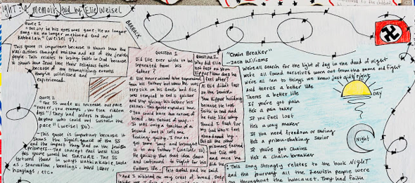
Examples:
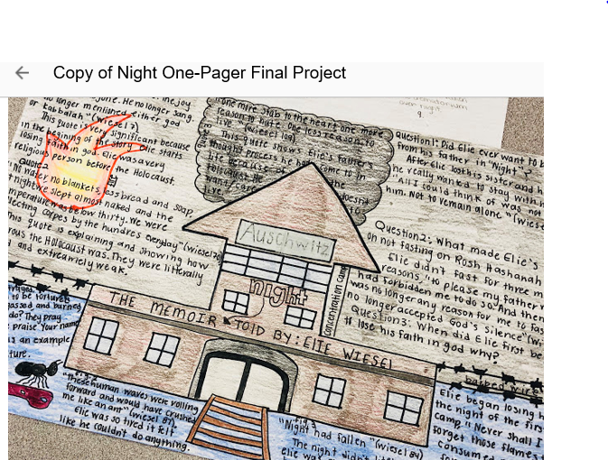

Name ___________________________________________________________________________________________
Hour _______________________________________________ Date _______________________________________

One Page Final Project Rubric
Requirements | Advanced | Proficient | Almost | Needs Improvement
Title, Author, Genre | All elements are present, correct, and creative. | All elements are present and correct. | One element may be missing or incorrect. | Multiple errors or not present
Quotes | All quotes are insightful, cited in MLA format, and reflect a critical part of the novel. The explanation is thorough. | All quotes are insightful, cited in MLA format, and reflect a critical part of the novel. The explanation is more simplistic. | There are three quotes. The citing may be off, and the explanation is more simplistic. The quotes also do not reflect critical parts. | The quotes are basic or missing. There are MLA citation errors. The explanation is simple and not in-depth.
Questions | All questions are insightful/ require higher-level thinking and analysis. | Questions are insightful/ require higher-level thinking and analysis. The answer includes a quote. | All three questions and answers are present. The answers include a quote. | The questions are basic or missing. The answers do not have a quote.
Setting | The images are labeled, detailed, thorough, and relate to the novel. | The images are labeled, detailed, and relate to the novel. | The images are labeled and relate to the novel. | There are no images, or they are not related.
Timeline | The images are labeled, detailed, thorough, and relate to the novel. | The images are labeled, detailed, and relate to the novel. | The images are labeled and relate to the novel. | There are no images, or they are not related.
Images | The images are labeled, detailed, thorough, and relate to the novel. | The images are labeled, detailed, and relate to the novel. | The images are labeled and relate to the novel. | There are no images, or they are not related.
Song | The chosen song lyrics connect to the theme in the book well and the explanations are thorough. | The chosen song lyrics somewhat connect to the theme in the book. The explanations are more simplistic. | The chosen song lyrics don’t always connect to the theme in the book. The explanations are simplistic. | The chosen song lyrics do not connect to the theme in the book. The explanations lack understanding.

Total Points = ______________________ Grade = ______________________
Teacher Comments:

