20 Common Grammar/Mechanics Mistakes

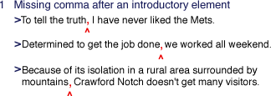
Check your sentences to see which ones open with an introductory word, phrase, or clause. Readers usually need a small pause between the introductory element and the main part of the sentence, a pause most often signaled by a comma. Try to get into the habit of using a comma after every introductory element, be it a word, a phrase, or a clause. When the introductory element is very short, you don't always need a comma after it. But you're never wrong if you do use a comma.

There are two common kinds of vague pronoun reference. The first occurs when there is more than one word that the pronoun might refer to; the second, when the reference is to a word that is implied but not explicitly stated.
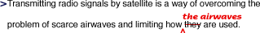
What is being limited—the signals or the airwaves?
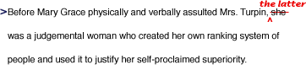
Whom does she refer to—Mary Grace or Mrs. Turpin? As edited, there is no doubt.
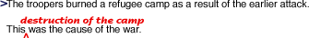
What does this refer to? The editing makes clear what caused the war.
What does which refer to—the policy or smoking? The editing clarifies the sentence.
Check your draft for clear backward reference of pronouns, words such as he, she, it, they, this, that, which, and who that replace another word so that it does not have to be repeated. Pronouns should refer clearly to a specific word or words (called the antecedent) elsewhere in the sentence or in a previous sentence, so that readers can be sure whom or what the pronoun refers to.

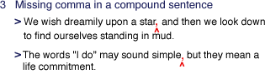
Check to see how many of the sentences in your draft are compound sentences, sentences made up of two or more parts that could each stand alone as a sentence. When the parts are joined by and, but, so, yet, nor, or for, insert a comma to indicate a pause between the two thoughts. In very short sentences, the comma is optional if the sentence can be easily understood without it. But you'll never be wrong to use a comma.

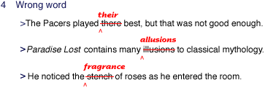
Wrong shade of meaning: a stench is a disagreeable smell; a fragrance is a pleasing odor.
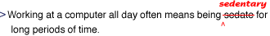
Wrong meaning: sedate means "composed, dignified" and sedentary means "requiring much sitting."
"Wrong word" errors come in many varieties. They can be among the hardest errors to check for, because you may not be able to see what's wrong. They can involve mixing up words that sound somewhat alike, using a word with the wrong shade of meaning, or using a word with a completely wrong meaning. Many "wrong word" errors are due to the improper use of homonyms—words that are pronounced alike but spelled differently, such as their or there. If wrong words are a problem for you, ask classmates or a teacher to help you scan your draft for them.
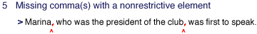
The reader does not need the clause who was the president of the club to know the basic meaning of the sentence: who was the first to speak. As a nonrestrictive (or nonessential) element, the clause is set off by commas.
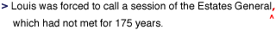
The reader does not need the clause which had not met for 175 years to understand which assembly the sentence is talking about because the Estates General has already been named. This clause is not essential to the basic meaning of the sentence and should be set off by a comma.
The reader knows which doll is Kristin's favorite—her first one; Malibu Barbie is thus not essential to the meaning of the sentence and needs to be set off by commas.
A nonrestrictive element is one that is not essential to the basic meaning of the sentence. You could remove it from the sentence and the sentence would still make sense. Check your draft to be certain you've used commas to set off any part of a sentence that tells more about a word in the sentence but that your reader does not need in order to understand the word or sentence.
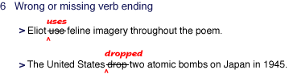
Check all of your verbs to make sure you have placed the proper endings on them. It's easy to forget the verb endings -s (or -es) and -ed (or -d) because they are not always pronounced clearly when spoken. In addition, some varieties of English use these endings in ways that are different from uses in standard academic English.

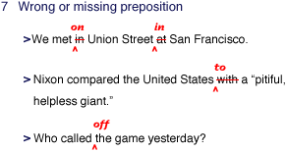
Check your draft by circling all the prepositions and making certain they are the ones you meant to use, because specific prepositions express specific relationships. Many words in English are regularly used with a particular preposition to express a particular meaning. Because many prepositions are short and are not stressed or pronounced clearly in speech, they are often left out accidentally in writing. Proofread carefully, and check a dictionary when you're not sure about the preposition to use.

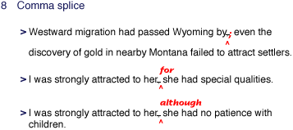
Check all the commas used in your draft for comma splices, which occur only when a comma separates clauses that could each stand alone as a sentence. To correct a comma splice, you can insert a semicolon or period, add a word like and or although after the comma, or restructure the sentence.

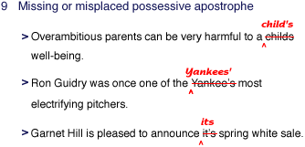
Check all of your nouns ending in -s to see if any of them are possessives. To make a noun possessive, you must add either an apostrophe and an -s (Ed's book) or an apostrophe alone (the boys' gym). Possessive personal pronouns, however, do not take apostrophes: hers, his, its, ours, yours.
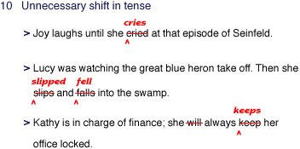
Check to make sure all the verb tenses in each of your sentences work together appropriately. Verb tenses tell readers when actions take place: saying "Willie went to school" indicates a past action whereas saying "he will go" indicates a future action. When you shift from one tense to another with no clear reason, you can confuse readers.

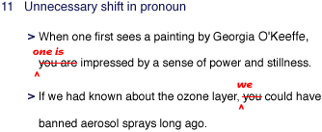
Check each pronoun in your draft for unnecessary pronoun shifts, which occur when a writer who has been using one kind of pronoun to refer to someone or something shifts to another pronoun for no apparent reason. The most common shift in pronoun is from one to you or I.

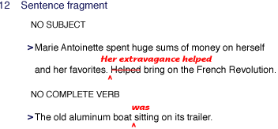
Sitting cannot function alone as the verb of the sentence. Adding the auxiliary verb was turns it into a complete verb, was sitting, indicating continuing action. Now this is a sentence.
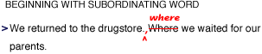
A sentence fragment is part of a sentence that is written as if it were a whole sentence, with a capital letter at the beginning and a period, question mark, or an exclamation point at the end. A fragment may lack a subject, a complete verb, or both, a fragment may depend for its meaning on the sentence before it. Check your draft for sentence fragments by reading it out loud, backwards, sentence by sentence. Out of normal order, sentence fragments stand out clearly.

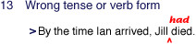
The verb died does not clearly indicate that the death occurred before Ian arrived.
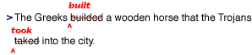
The verbs build and take have irregular past-tense forms.
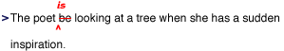
Errors of wrong tense or wrong verb form include using a verb that does not indicate clearly when an action or condition is, was, or will be completed—for example, using walked instead of had walked, or will go instead of will have gone. Some varieties of English use the verbs be and have in ways that differ significantly from their use in standard academic or professional English. Errors may occur when a writer confuses the forms of irregular verbs (like begin, began, begun or break, broke, broken) or treats these verbs as if they followed the regular pattern—for example, using beginned instead of began, or have broke instead of have broken.

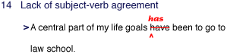
The subject is the singular noun part, not goals.
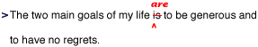
Here, the subject is the plural noun goals, not life.
If a subject has two or more parts connected by and, the subject is almost always plural.
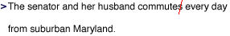
If a subject has two or more parts joined by or or nor, the verb should agree with the part nearest to the verb.
Here, the noun closest to the verb is a singular noun. If this construction sounds awkward, consider the next edit.
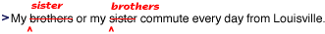
Now the noun closest to the verb is a plural noun, and the verb agrees with it.
Collective nouns such as committee and jury can be treated as singular or plural, depending on whether they refer to a single unit or multiple individuals.
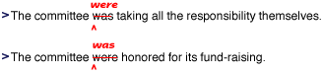
Most indefinite pronouns such as each, either, neither or one are always singular and take a singular verb. The indefinite pronouns both, few, many, others and several are always plural and take plural verb forms. Several indefinite pronouns (all, any, enough, more, most, none, some) can be singular or plural depending on the context in which they are used.
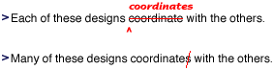
The relative pronouns who, which or that take verbs that agree with the word the pronoun refers to.
Check your draft for subject-verb agreement problems by circling each sentence's subject and drawing a line with an arrow to that subject's verb. You should be able to do this for each sentence. A verb must agree with its subject in number and in person. In many cases, the verb must take a form depending on whether the subject is singular or plural: The old man is angry and stamps into the house, but The old men are angry and stamp into the house. Lack of subject-verb agreement is often just a matter of leaving the -s ending off the verb out of carelessness, or of using a form of English that does not have this ending. Sometimes, however, this error results from particular sentence constructions.

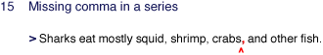
Check your draft to see if you've written any sentences containing items in a series. When three or more items appear in a series, they should be separated from one another with commas. Some newspapers do not use a comma between the last two items, but the best advice is that you'll never be wrong to use a series comma because a sentence can be ambiguous without one.

Some pronoun problems occur with such words as each, either, neither, and one, which are singular and take singular pronouns.
Problems can also occur with antecedents that are joined by or or nor.
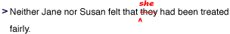
Some problems involve words like audience and team, which can be either singular or plural depending on whether they are considered a single unit or multiple individuals.
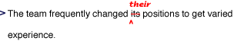
Because team refers to the multiple members of the team rather than to the team as a single unit, its needs to be changed to their.
The other kind of antecedent that causes problems is an antecedent such as each or employee, which can refer to either man or women. Use he or she, him or her, and so on, or rewrite the sentence to make the antecedent and pronoun plural or to eliminate the pronoun altogether.
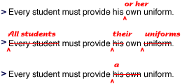
Check your draft for all uses of pronouns, words such as I, it, you, her, this, themselves, someone, and who that replace another word (the antecedent) so that it does not have to be repeated. Pronouns must agree with their antecedents in gender (for example, using he or him to replace Abraham Lincoln and she or her to replace Queen Elizabeth) and in number (for example, using it to replace a book, and they or them to replace fifteen books).
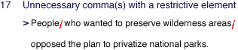
The reader needs the clause who wanted to preserve wilderness areas because it announces which people opposed the plan. As an essential element, the clause should not be set off by commas.
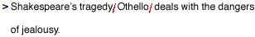
The reader needs to know which of Shakespeare's many tragedies this sentence is talking about. The title Othello is therefore essential and should not be set off by commas.
Check any words or phrases in your draft set off with commas to make sure that the element set off is not a restrictive element, one essential to the basic meaning of the sentence. Such essential words or phrases are not set off from the rest of the sentence with a comma or commas.

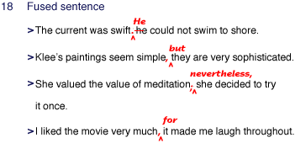
Check each of the sentences in your draft to make certain it is not a fused sentence (also called a run-on sentence). Fused sentences are created when clauses that could each stand alone as a sentence are joined with no punctuation or words to link them. Fused sentences must either be divided into separate sentences or joined by adding words or punctuation.

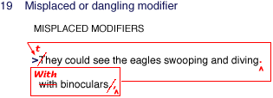
Who was wearing the binoculars—the eagles?
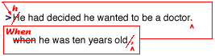
What kind of a doctor could he be at age ten?
Did the architect only consider but then reject pine paneling?
Check every modifier (whether a word, phrase, or clause) to make sure that it is as close as possible to the word it describes or relates to. Be on the lookout for misplaced modifiers that may confuse your readers by seeming to modify some other word, phrase, or clause.
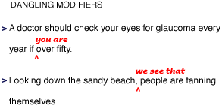
Check your draft for dangling modifiers: phrases hanging precariously from the beginning or end of a sentence, attached to no other word in the sentence. The word that the phrase modifies may exist in your mind but not on paper. Proofread carefully to ensure that each modifier refers to some other word in the sentence.

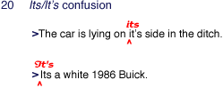
Use its to mean belonging to it; use it's only when you mean it is or it has.

